Roundhouse Access Information
Contents
Introduction 3
Contact details 3
Opening hours 3
Venue description 3
Travel guide 5
By train 5
By bus 6
By car 7
Parking 7
Arrival guide 8
Key information 8
Arriving at the Roundhouse 9
Inside the Roundhouse 11
Leaving the Roundhouse 11
Accessible facilities 11
Hearing Impaired Visitors 12
Venue accessibility for wheelchair users 12
Toilets 12

Date of creation | 23/11/2020 | Document owner | Anna Jukes
Last updated | 17/01/2023 | Updated by | Anna Pickton
Sign-off date |  | Signed off by
Version # | V2.1

Assistance animals 13
Quiet space 13
Customers with medical requirements 13
Nursing mums 13
Bookable access facilities and how to apply 14
Ticket collection 15
Strobe lighting 15
Visiting Roundhouse offices and tenants 16
Event Space – West Gatehouse 16
National Trust 16
Canal and River Trust 17
Ristorante Café Arena… 17
Sustrans – east gatehouse 18
Sensory access… 19

Roundhouse Access Information Page 2 of 20

Introduction
Here at Roundhouse Birmingham, everyone is welcome. We are committed to making all aspects of your visit as enjoyable, welcoming, and physically accessible as possible. We are working hard to make sure we provide a warm welcome to our visitors and thank you for any comments you might have about improvements we could make that would help make your visit easier for you.

Contact Details
You can talk to any member of the Roundhouse team about any requirements you might have during your visit. However, if you would like to get in touch in advance, please do use our dedicated email address access@roundhousebirmingham.org.uk or call the Visitor Centre on 0121 716 4077 to talk to someone before you arrive.
We’re not open every day of the week, but we do try to respond to all enquiries
within two days.

Opening Hours
Our standard opening hours are:
09:30am – 4:30pm, Wednesday to Sunday
The restaurant opening hours may differ from this, so please check their website for further information: https://www.arenaltd.co.uk/

Venue Description
Built in 1874, the Roundhouse is a Grade 2* listed building. With its curious horseshoe-shaped structure accompanied by two gatehouses, the Roundhouse was

Page 3 of 20

originally the site for lamplighters, stonebreakers and tradesmen who contributed to the improvements and functions of the city. The main building would have stabled up to 50 working horses, with the archways and under crofts used as workshops and for storage.
We have step-free access to lots of parts of the building – these include the toilets, café, Visitor Centre, and Display Space.
Please be aware that Roundhouse Birmingham is built on a fairly steep slope and is laid to cobbles. It is therefore uneven underfoot. However, there is a clear route designed to be accessible for wheelchair users, pushchairs, and visitors with restricted mobility.
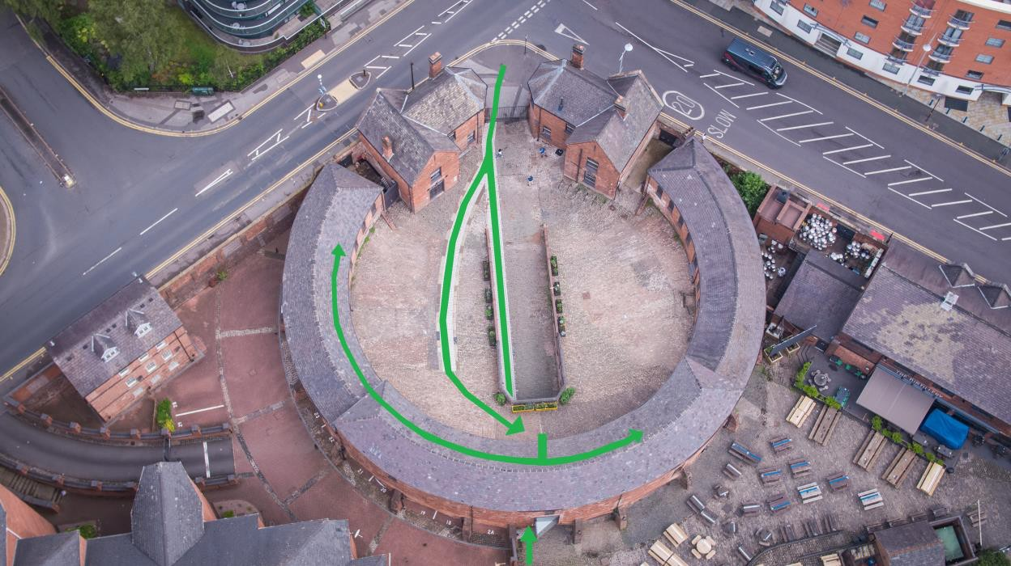

Roundhouse Access Information Page 4 of 20

Travel Guide
There are a number of transport options available for getting to the Roundhouse. As a city centre building, please leave plenty of time to find us.

By train
Roundhouse is around 1 mile from the following Birmingham train stations. All train stations have step-free access. There are taxi ranks outside Birmingham Snow Hill and Birmingham New Street stations.
Birmingham Snow Hill (0.9 mile) https://goo.gl/maps/Vyt8owBehrkmnhHu6
Five Ways (1 mile) https://goo.gl/maps/qpBKp5hGg3G1Kp9bA
Birmingham New Street (1.1 miles) https://goo.gl/maps/hVyer52cv9Xt6FqcA

Roundhouse Access Information Page 5 of 20

By bus
Buses run past the Roundhouse throughout the day, including from those from the City Centre. Most buses run from Colmore Row, which is directly outside of Birmingham Snow Hill train station. There is a bus stop just outside the building on Sheepcote Street which is the closest, however many more buses and the trams stop on Broad Street. Visit networkwestmidlands for more details or see below.

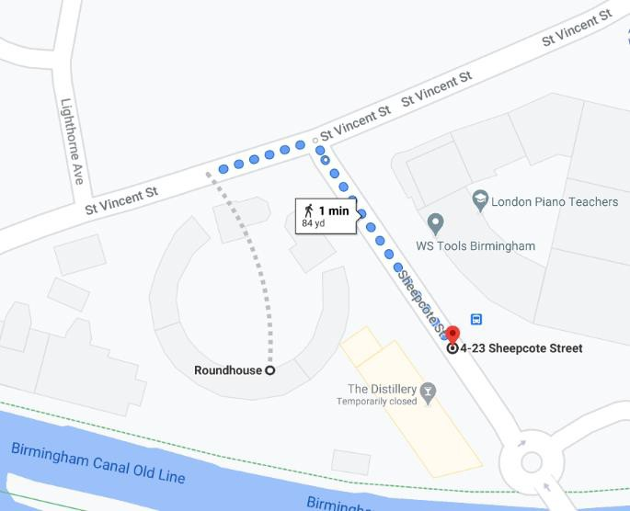
Bus 126 stops immediately outside of the Roundhouse (one minute walk from the front gates)

Broad Street is approximately a ten-minute walk from the front gates on the Roundhouse. Turn right outside of the gates and follow the road to the top of Sheepcote Street. There are more buses available from the City Centre as well as the tram. The buses from Colmore Row include the 9, X10, 12A, 13, 23 & 24.

Page 6 of 20

By car
If you’re driving to the Roundhouse, we’d suggest you leave plenty of time for your journey. We’re in the heart of the city next to the canals and easy to get to. Live traffic updates can be found at www.gov.uk/traffic-information.

Parking
Roundhouse is completely pedestrianised, and therefore has no parking. The nearest car park is Arena Birmingham South Car Park, the entrance to which is about 300ft away.
Accessible parking bays are located on Level 9 of the North Car Park, off King Edward’s Road, or in the South Car Park, off Sheepcote Street (but please note that lifts can sometimes be out of action in the South Car Park). Disabled visitors arriving in vehicles over 2m in height need to head to the North Car Park. Here visitors can disembark, and traffic officers will then direct the vehicle to the nearest parking bay.
If you display your Blue Badge, parking is free at pay-and-display on-street parking bays (with no time limits) and in council car parks. There are a small number of parking bays on St Vincent Street. See the Birmingham City Council website for more details https://www.birmingham.gov.uk/bluebadgeparking

Roundhouse Access Information Page 7 of 20

Arrival Guide

Key information
The Roundhouse is a Grade 2* listed building. Corridors and doorways are narrow.
The site is built on a relatively steep slope and laid to cobbles. There is step-free access to all public parts of the building.

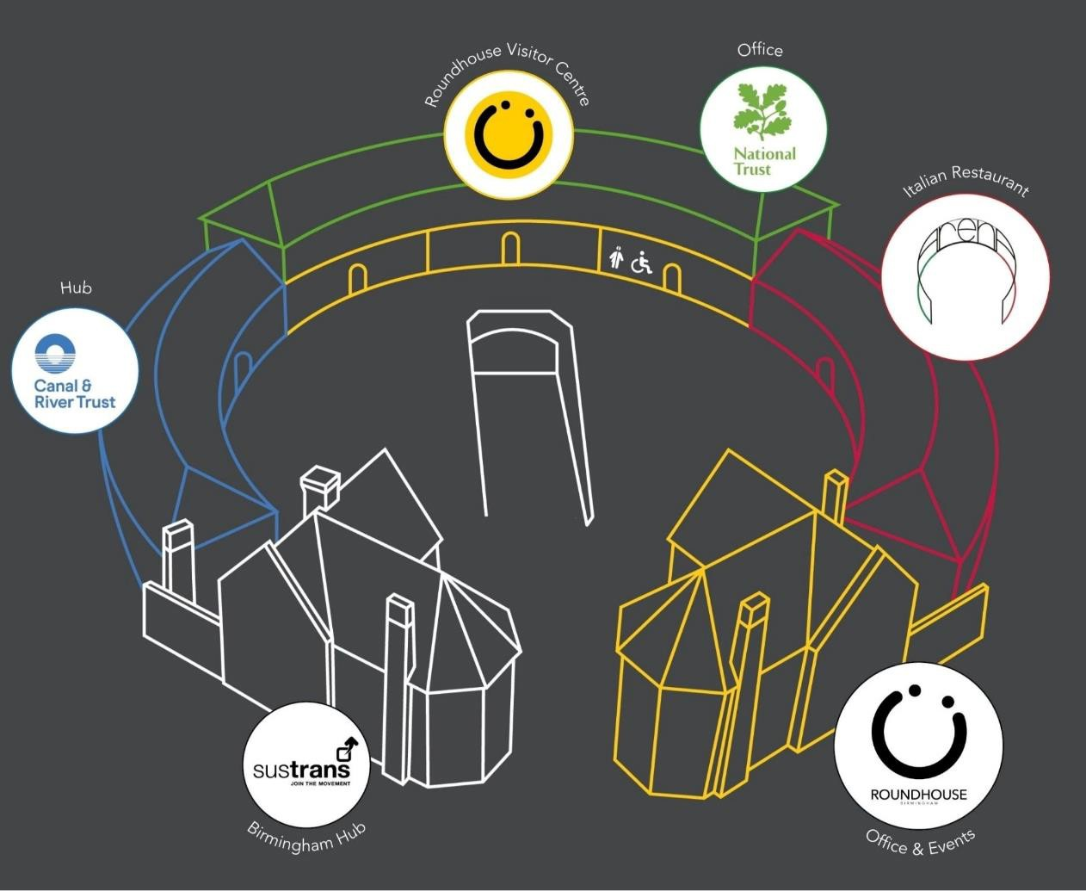

Roundhouse Access Information Page 8 of 20

Arriving at the Roundhouse
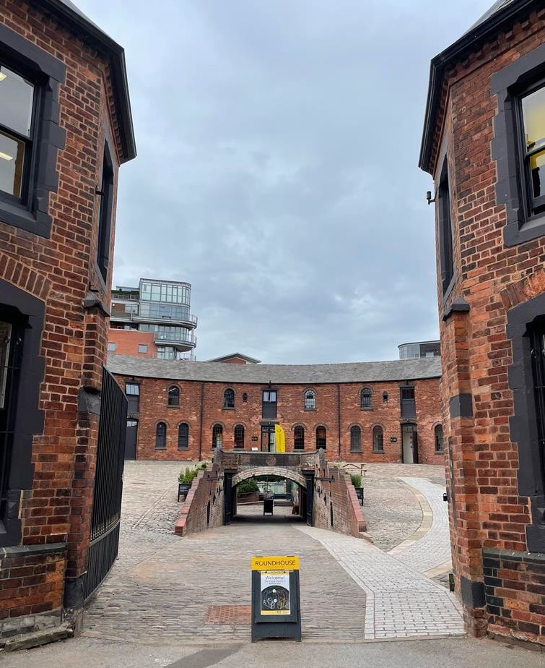
You can enter the main building from one of two directions:
Main entrance into courtyard
If approaching the building from Sheepcote Street/St Vincent Street, you will enter between the two gatehouses straight into the inner courtyard. The inner courtyard is laid to cobbles. In front of you is a tunnel sloping gently downwards towards the lower courtyard and then onto the canal tow path. Click here to watch a video on how to get there.

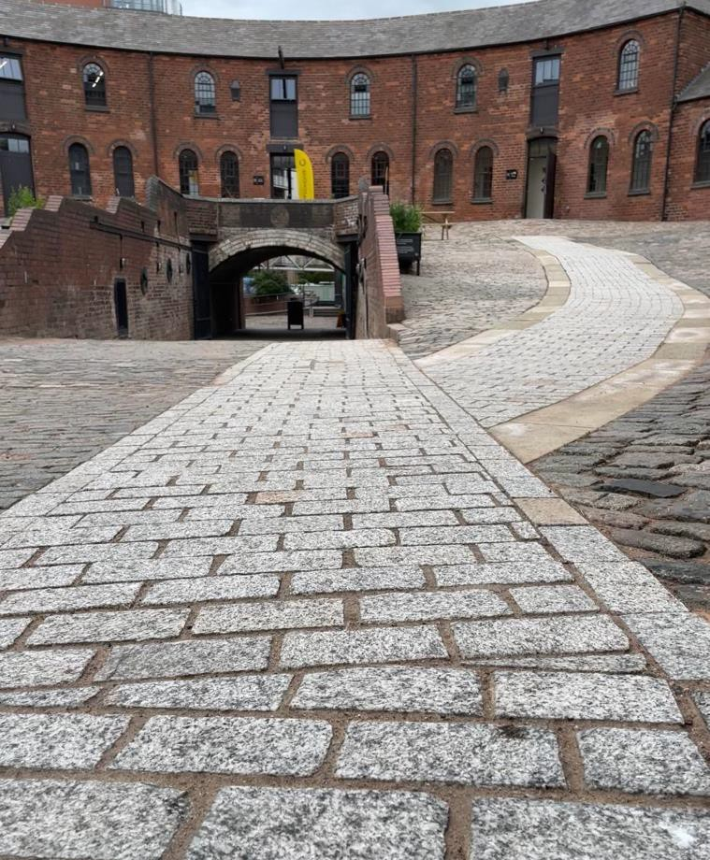
To the right of the tunnel there is a clear route with flat paving that we recommend all visitors use to approach the main building. Please note that the whole inner courtyard is built on a slope. Access to the visitor centre, café and toilets is up a steep uphill slope. Click here to watch a video on how to access via the paved route.
Main courtyard step-free route

Roundhouse Access Information Page 9 of 20

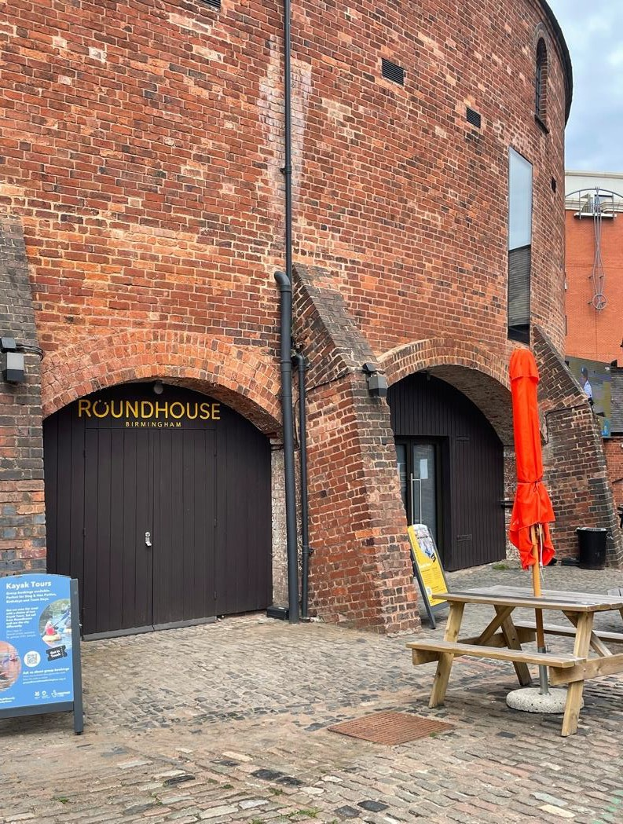
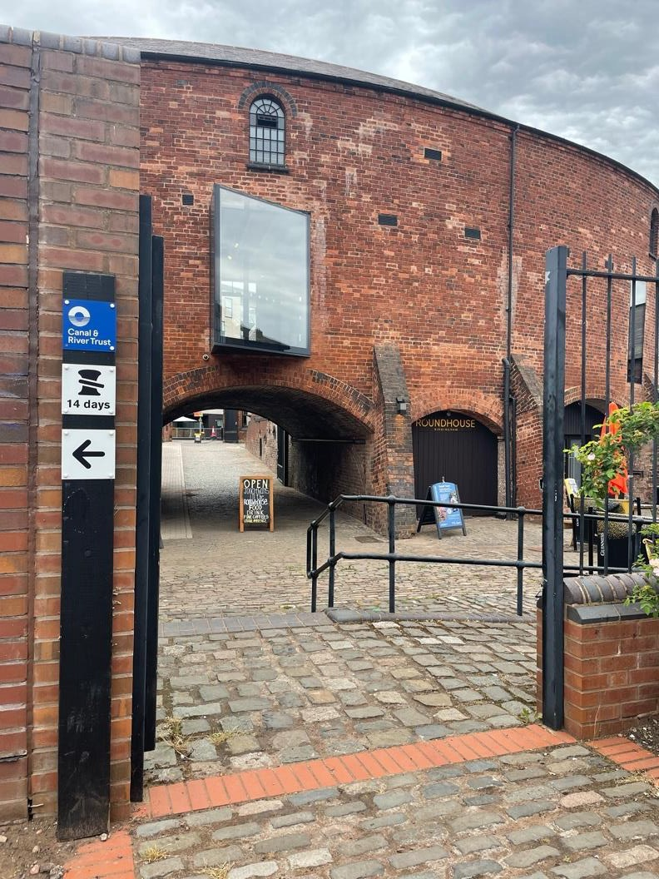
If approaching the building from the canal tow path, you will first enter the Distillery pub courtyard. We recommend you enter this courtyard via the furthest left gate (in front of the big window) and use the ramp. This route avoids the pub garden and brings you onto the lower courtyard at the bottom of the Roundhouse tunnel entrance to the inner courtyard. The tunnel is built on a slight slope and is laid to cobbles. Both the lower courtyard and Distillery courtyard are cobbled. Click here to watch a video on how to get there.
Lower courtyard activity archways
Lower courtyard entrance. Ramp to right, tunnel through to main entrance

Access to both our activity archways on the lower courtyard are step-free via cobbles. Click here to view a video of our activity archways.

Roundhouse Access Information Page 10 of 20

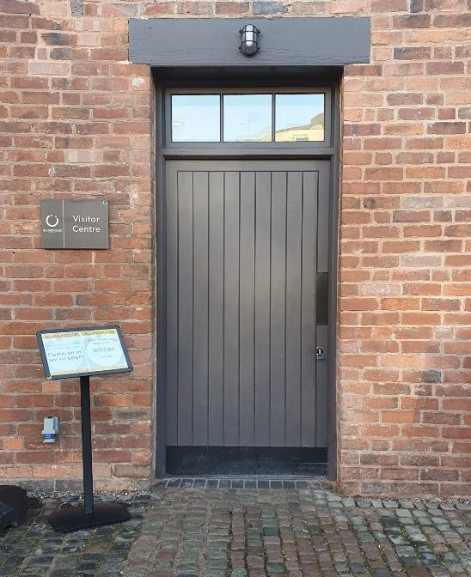
Inside the Roundhouse
Visitor Centre doorway
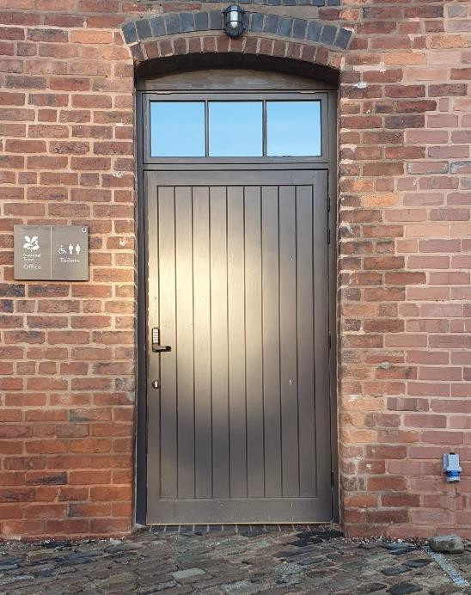
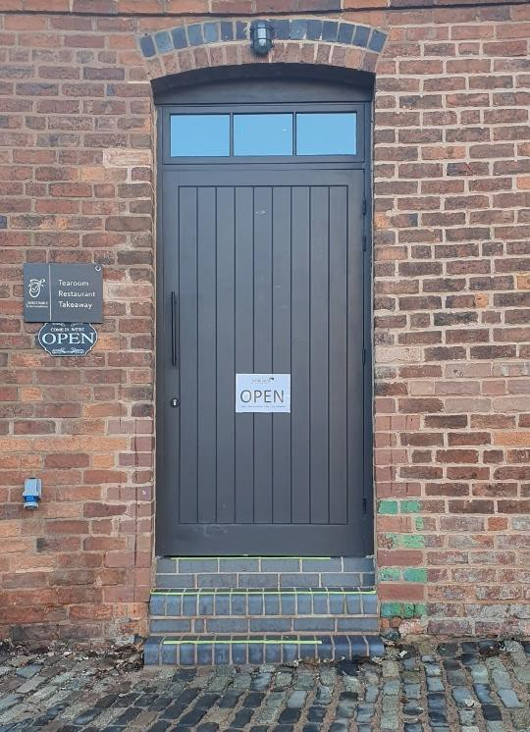
The three central doors to the main building provide step-free access. From here you can enter all parts of the building internally. The central door takes you into the Visitor Centre – turning left will take you through to the Display Space and turning right will take you to the toilets and then onto the restaurant.
Restaurant external doorway (Step-free route internally)
Toilet entrance doorway
The remaining doors to the main building have steps to enter them from the inner courtyard.
The door to the Restaurant has three steps.

Leaving the Roundhouse
You can leave the Roundhouse either via the main gates between the gatehouses or via the tunnel and onto the tow path.
Accessible Facilities

Roundhouse Access Information Page 11 of 20

Accessible Facilities

Hearing Impaired Visitors
Roundhouse Birmingham Visitor Centre is equipped with an induction hearing loop. You will need to switch your hearing aid to the ‘T’ position to make use of this system.
On each of our tours, we will be using audio systems to ensure our visitors can hear us. We provide headsets, or if you wear a hearing aid, we can provide you with an inductive neck loop to wear. The loop works with analogue and digital hearing aids set to the ‘T’ position.

Venue accessibility for wheelchair users
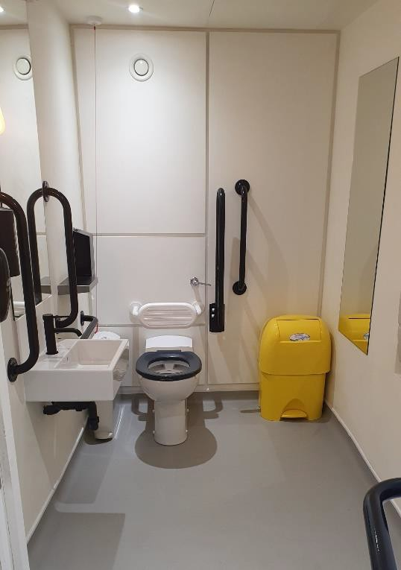
We have a lowered counter position at our welcome desk in the Visitor Centre, and the public areas within our building are fully wheelchair accessible, including the Visitor Centre, Display Space, toilets, and café.
Accessible toilet

Toilets
Roundhouse has one block of toilets. These are located to the right of the Visitor Centre and to the left of the café. There are four single all-gender toilets and one all-gender disabled toilet/baby change. We do not currently offer a Changing Places toilet facility.

Roundhouse Access Information Page 12 of 20

Assistance Animals
Assistance animals are very welcome. You can keep them with you in all spaces at the Roundhouse, and they’re also welcome on all our tours. Please do get in touch with us in advance of your tour so we can discuss your individual requirements and ensure you have the best tour experience possible.

Quiet Space
We can provide access to somewhere quiet if you need a place to get away from crowds, noise, and lights. We are also making this space available for those who wish to pray, a quiet place for taking medication, etc. Please speak to a member of staff if you wish to make use of this space. Click here to watch a video on step-free quiet space access.

Customers with Medical Requirements
We welcome visitors who need to bring medicines, medical equipment, food or drink to manage a medical condition. If you have any concerns, please don’t hesitate to get in touch. We can also provide access to a quiet space should you wish for some privacy.

Nursing Mums
Nursing mums are very welcome – in the café, in the courtyard, in our Visitor Centre or wherever is most comfortable. We can also provide access to a quiet space should you wish for some privacy.

Roundhouse Access Information Page 13 of 20

Bookable access facilities and how to apply
We are happy to offer complimentary tickets for Personal Assistants (PA). PA tickets are available for any disabled person who has purchased a ticket for a tour and would be unable to attend without the help of their PA. Your PA must be able to assist you to access the Roundhouse and facilities, remaining with you to ensure your well-being and comfort. Anyone designated as a PA must be physically able to assist the person they are with to leave the building in the event of an emergency.
To book your free personal assistant ticket, please either call the Roundhouse on 0121 716 4077 or pop into the Visitor Centre to speak with a member of our team in person, who will happily process the tickets on your behalf. If you have any questions, you’re more than welcome to also email us
on access@roundhousebirmingham.org.uk.
Please note you may be required to provide the below forms of copied evidence. Although we will review an application without the recommended evidence on a case- by-case basis.
- Front page of DLA / PIP Entitlement
- Front page of Attendance Allowance letter
- Evidence that registered severely sight impaired
- Recognised Assistance Dog ID card
We want everyone to be able to take part in our tours, events and activities and enjoy our building. If you have a specific requirement or question, please get in touch so we can make sure you have the best possible experience access@roundhousebirmingham.org.uk.

Roundhouse Access Information Page 14 of 20

Ticket collection & Checking In

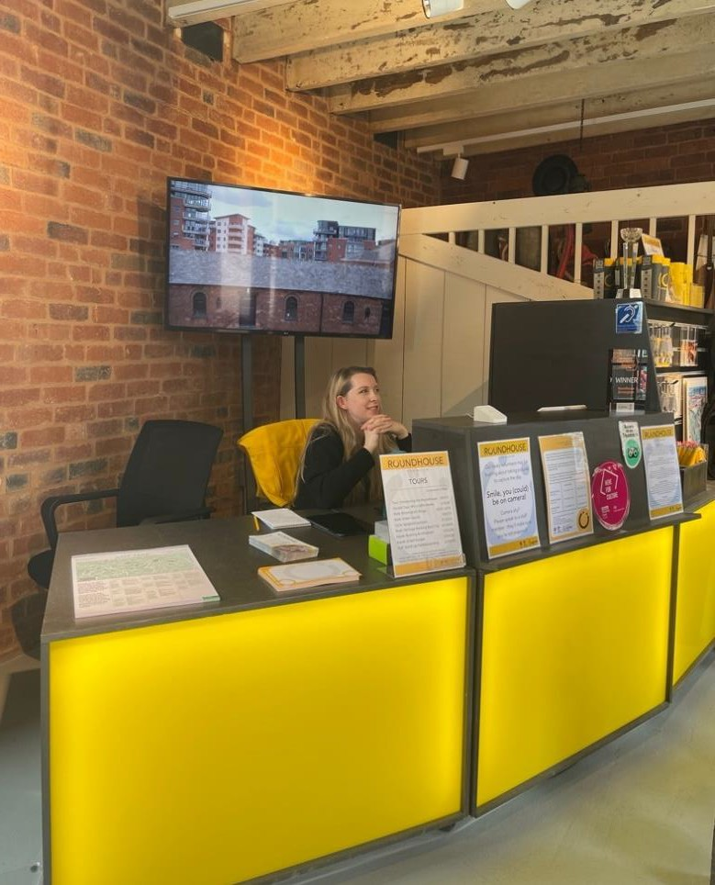
To purchase or collect your tickets, or check in for a pre-booked tour, please head to the Visitor Centre. You will need some form of identification to collect pre- paid tickets – a payment card will be fine. If a member of your party has booked a concession ticket, they may be required to show proof of eligibility. Once you have collected your ticket/s, a member of staff will direct you to the meeting point for the start of the tour.
Strobe Lighting
Visitor Centre desk

None of our tours make use of strobe lighting. Occasionally events or performances will use strobe lighting. We do our best to dissuade visiting productions/companies from doing so as we appreciate it will prevent some people from attending. We will update the relevant event information page on our website if it is being used. If you have any concerns, please get in touch. If strobe lighting is being used as part of a performance that you have purchased tickets to, we will of course offer a refund or exchange.

Roundhouse Access Information Page 15 of 20

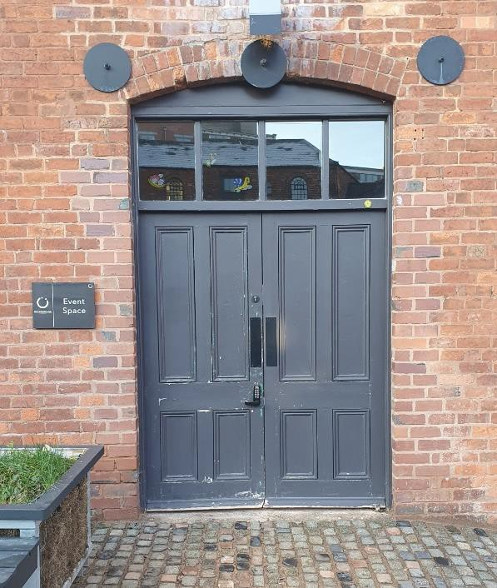
Visiting Roundhouse Offices and Tenants
Step-free access to Event Space
Entrance to accessible lift to National Trust offices

Event Space – West Gatehouse
The Event Space is located on the ground floor of the West Gatehouse. Access to the room is step-free. The nearest accessible toilet is in the Main Building.

National Trust
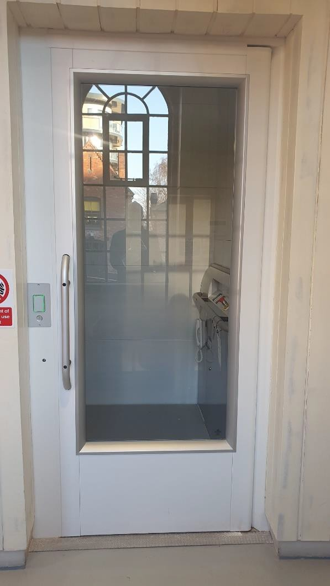
The National Trust offices are located in the Main Building on the first floor. If you are able to use stairs, please enter the building via the door to the toilets and turn right. If you require use of a mechanical lift, use the door to the left of the Visitor Centre and turn left. Please ensure your National Trust host is expecting your visit. The first floor has an accessible toilet located at the other end of the office to the lift. In the case of emergency, the lift is not to be used for evacuation. Refuge points are located at the top of each staircase. Click here for a video guide.

Roundhouse Access Information Page 16 of 20

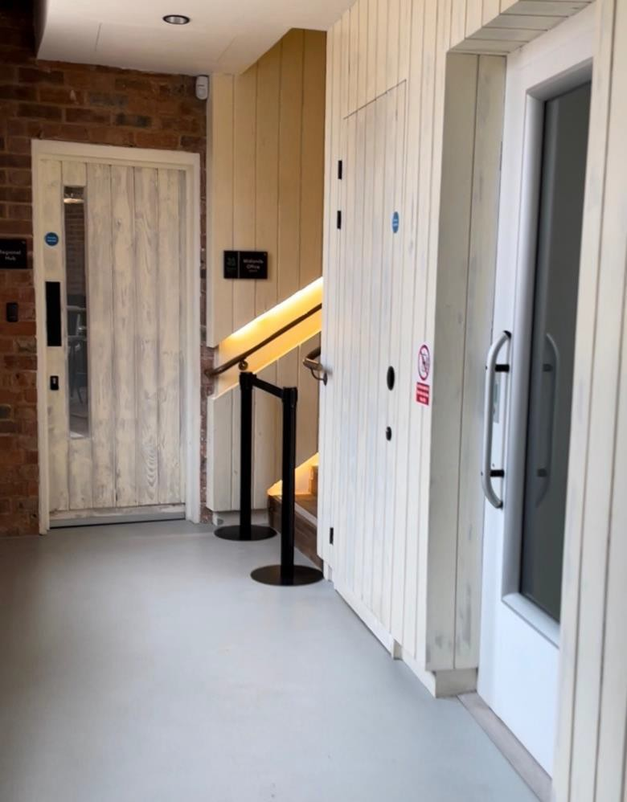
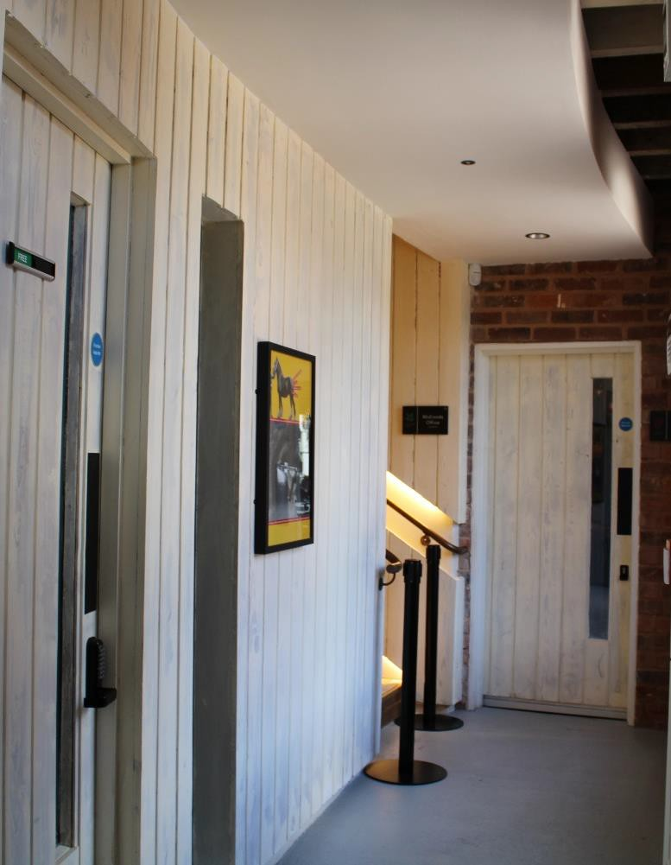
Canal & River Trust
Step-free internal access to Ristorante Café Arena
Step-free internal access to Canal & River Trust offices
The Canal & River Trust (CRT) are located in the main building on the ground floor, to the left of the Visitor Centre. Please enter the building via the door to the left of the Visitor Centre and turn left. Pass the stairs, and the CRT hub is in front of you. The public toilet block are the nearest loos. Click here to access the CRT hub step-free.

Ristorante Caffe Arena
Ristorante Caffe Arena is an independent Italian Restaurant. Step-free access can be gained internally by entering the building using the doors to the toilets and turning right. The nearest accessible toilets are the main public toilets. Click here for a video guide.

Roundhouse Access Information Page 17 of 20

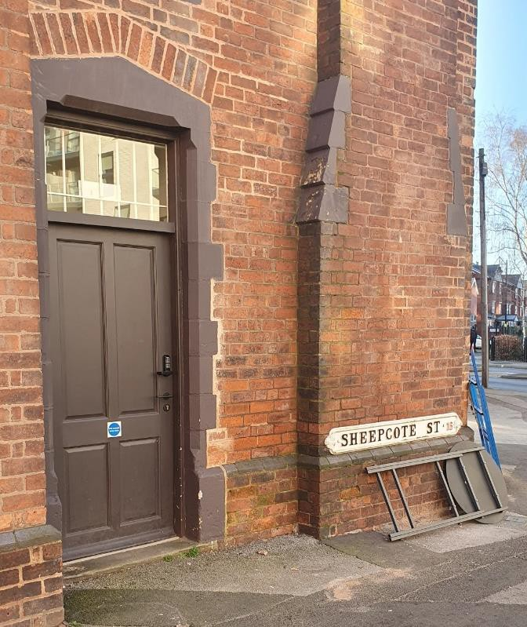
Sustrans – East Gatehouse
Step-free access to Sustrans Hub from Sheepcote Street
Sustrans are based in the East Gatehouse. Step-free access can be gained through the front door from Sheepcote Street. An accessible toilet is located within the East Gatehouse. Click here for a video guide showing a step-free access to Sustrans.

Roundhouse Access Information Page 18 of 20

Sensory Access

Quiet Time
Wednesday-Sunday mornings from 9.30am-10am.

This is a time when there are usually fewer visitors to the Roundhouse Visitor Centre, and we will make some changes during this time to reduce sensory input.

Sound:
The fan heaters currently installed in the Visitor Centre will be turned off to minimise the noise. There is a loudspeaker in the Horse Stall which plays sounds from a working industrial yard with horses. This is triggered by a motion sensor. This will be turned off.

Light:
There are several screens, displays and lights in the Visitor Centre and Display Space: A large TV screen behind the welcome desk, playing video footage and photographs showing the Roundhouse renovation works and the types of tours and activities we
deliver. A large projector screen in the Display Space, playing animations which tell the stories of the people who worked at the Roundhouse. This also has sound – a combination of music and spoken word – which will be turned off during this period. (The sound for this can be turned back on, on request). There are two large floor-to- ceiling windows that provide plenty of natural light in the Visitor Centre and Display Space.

A sensory map of the Roundhouse Visitor Centre and Display Space is free to download here: Sensory Map of VC.pdf

Roundhouse Access Information Page 19 of 20

Sensory Bag
Our sensory bag is a collection of items designed to be useful for a variety of sensory needs. Inside our sensory bag, there is an array of items such as fidget toys, a magnifying glass, sunglasses, and ear defenders.

This bag and its contents are available for anyone to borrow whilst exploring our site or participating in our on-site tours. To use our sensory bag, please ask a member of staff.

Roundhouse Access Information Page 20 of 20

